Peninsula Images
Note: These images can be matched up with the map of Peninsula provided in “Locating the Site”
Mainstreet, Peninsula looking east across the Main Street Bridge
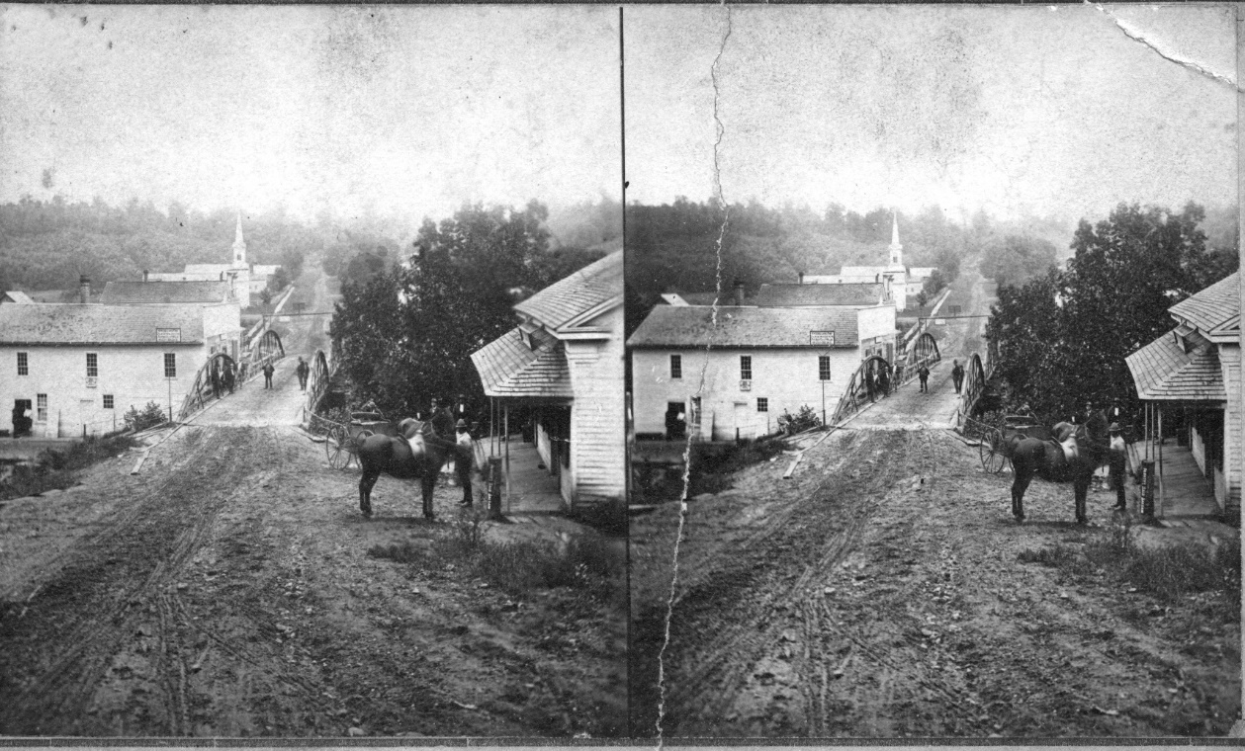
Source: Peninsula Library Historical Society
Post Civil War stereoscope image looking across the Main Street Bridge of which the near span crosses the canal and the far span crosses the river. Merrill Boodey’s store was just beyond, on the left (north) side after the bridge.
Question: How does the geography of the town focus on the canal and, judging from this photo, why might the canal have remained a main means of transportation following the Civil War?
Birdseye View of Peninsula looking west from Woods Hill
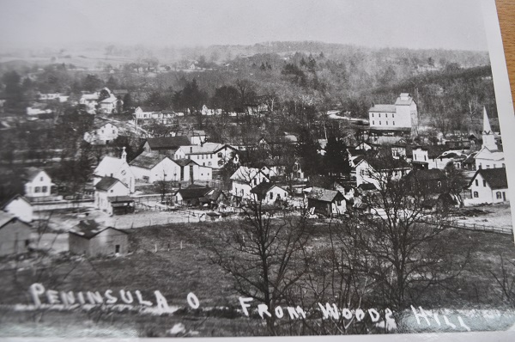
Source: Cuyahoga Valley National Park Archives
Post-Civil War image showing 2 of 3 churches in town, the new grist mill in the back-ground between the river and the canal, and the collection of stores and hotels along Main Street.
Question: Where, in relation to the business district in town do private homes and residences seem to be located? Which direction does the town seem to be growing?
Gristmill and Canal Aqueduct across the Cuyahoga River and Lock just north of Main Street, Peninsula
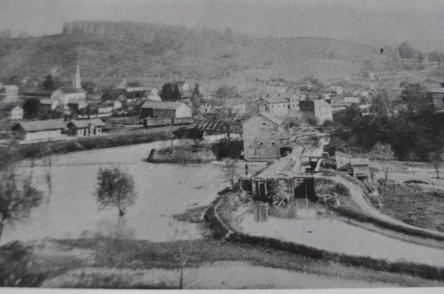
Source: Cuyahoga Valley National Park Archives
Post-Civil War image looking south towards Main Street. The Valley RR Station (opened in 1880 is just left of the river is by the box-cars) The river is high. In the fore-ground to the right is the canal below Lock 29, the Aqueduct, and the original grist mill.
Question: How might there be business enough for both the Railway and the Canal (as suggested in the 1864 Report of the Board of Public Works?) to secure the future of Peninsula after the Civil War?
Industry along the Cuyahoga River and Ohio and Erie Canal just south of the Main Street Bridge in Peninsula
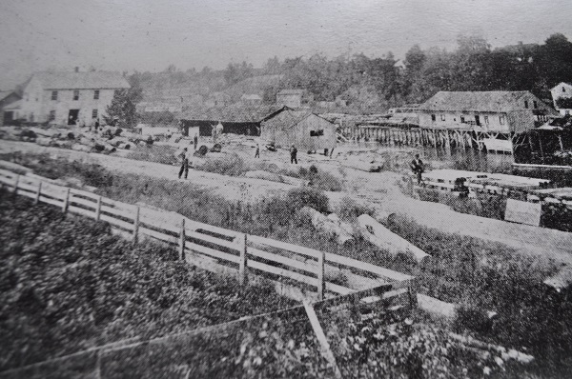
Source: Cuyahoga Valley National Park Archives.
Post Civil War image looking west across the newly graded bed for the Valley Railway of the town’s manufacturing area along the river in the foreground and the canal in the background.
Question: What sort of work does it seem would be available to keep returning Civil War veterans in town in Peninsula?

